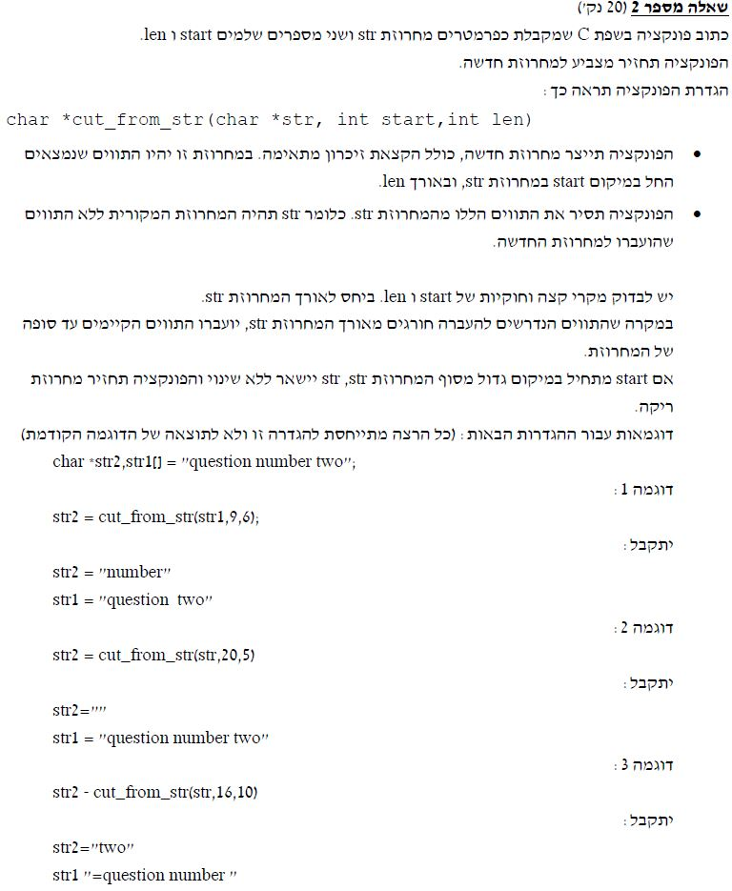

#include <stdio.h>

#include <stdlib.h>

#include <string.h>

// Answer 2 Mahat Summer 2018 B

// This func gets string and takes from start-len off of it.

// Will put the start-len in other string using dynamic allocation

char *cut_from_str(char *str, int start, int len)

{

//Memory calloc for str2 string by the size of str

char *str2 = (char *)calloc(strlen(str), sizeof(char));

int i, j = 0;

//Checking the start and len to be right

if (start < strlen(str) && len < strlen(str))

{

//Placing the chars from str in to str2 by start and len

for (i = start; i <= start + len; i++)

{

str2[j] = str[i];

j++;

}

str2 = (char *)realloc(str2, len);

//Closing str2

str2[len] = '\0';

i = 0, j = 0;

//Removing the char’s placed in str2 from str

while (str[i])

{

if (i < start || i >= start + len)

str[j++] = str[i];

i++;

}

//Closing str;

str[j] = '\0';

}

return str2;

}

int main()

{

char *str2, str1[] = "question number two";

printf("str1 : %s\n", str1);

str2 = cut_from_str(str1, 9, 6);

printf("str2 : %s\n", str2);

printf("str1 : %s\n", str1);

getchar();

getchar();

}